**Start at create order page. Enter customer ID from list below.**

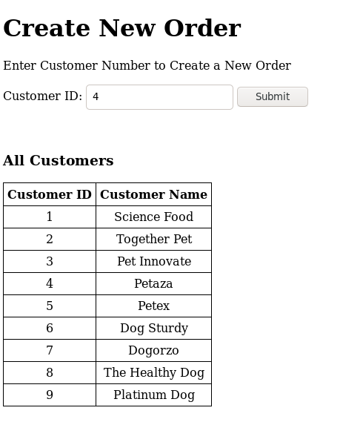

**You will then be taken to a page which has your order number. Note this number. Click on the link below to navigate to the page where you will be entering lines into the order.**

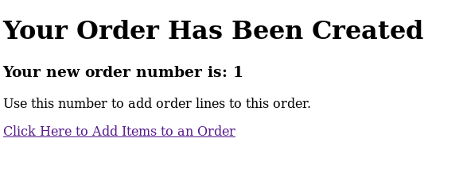

**At this point, you will be able to enter the order number that was provided to you in the last step. If you want to see what inventory is available, click on the link for the inventory (this will be shown at the end). Once you have added all items to the order, you can preview/review the in-progress/completed order by clicking on to the second link.**

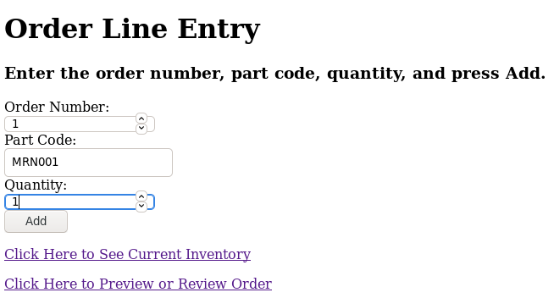

**To preview/review the order, you will enter the order number that you were just working on. You also can use the visible table below which shows all orders to select an order number.**

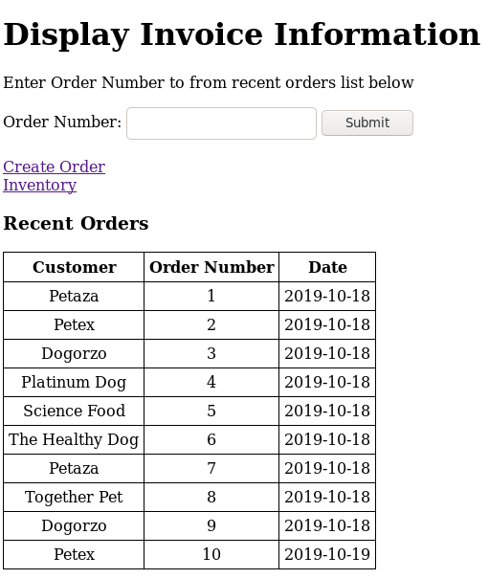

**Once you have selected an invoice, you will be brought to a page where you can see the customer invoice.**

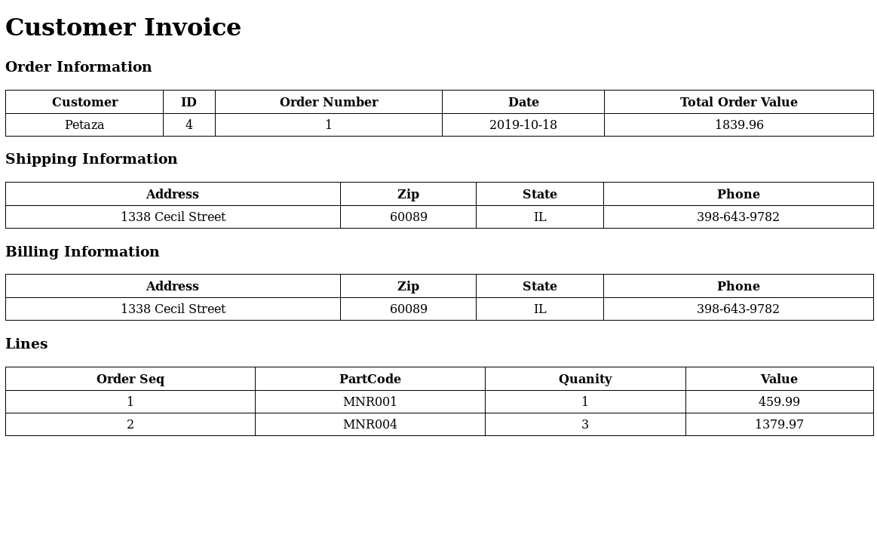

**If you had selected the inventory link on the order line entry page, you would have been brought to this page where you can then navigate and do the following:**

1. **View current inventory**
2. **See total inventory value**
3. **Add a new product**
4. **Delete a product from the inventory table**

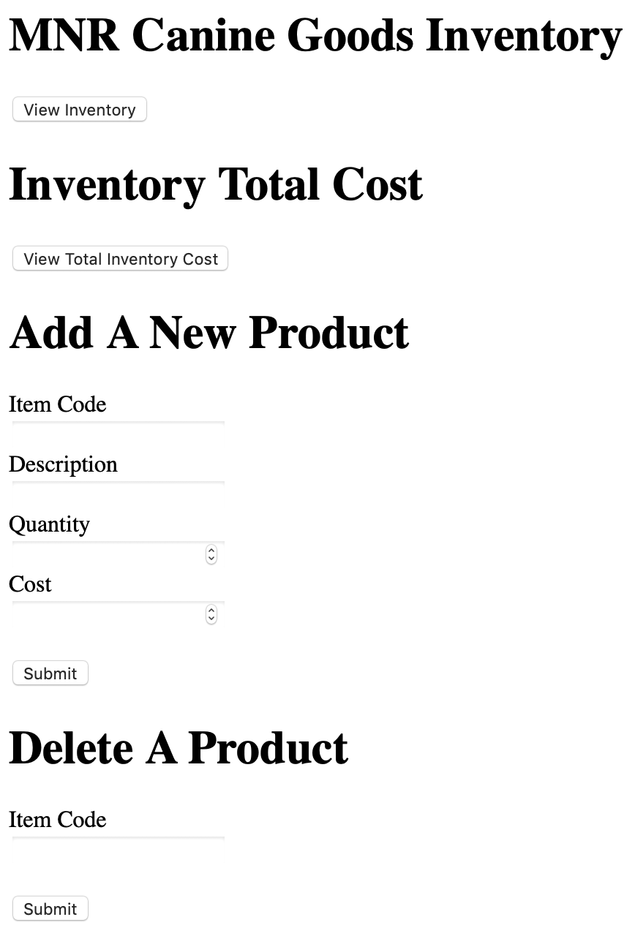

**If you select View Inventory, then you will get a preview of all the inventory.**

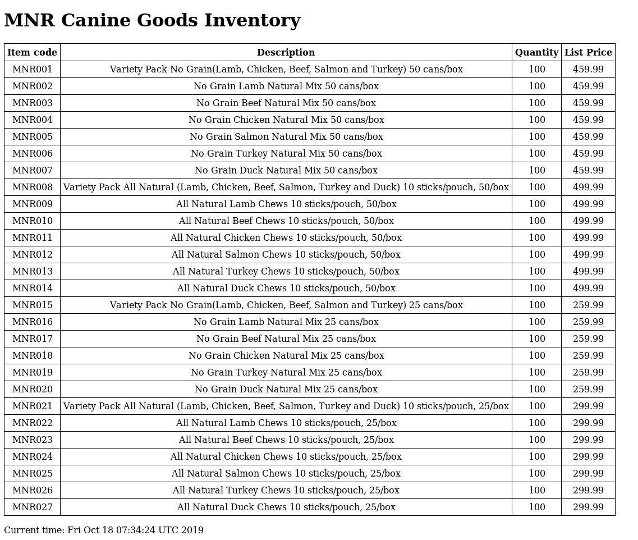

**If you select the link to view total inventory cost, you will get a simple sum of all inventory values.**

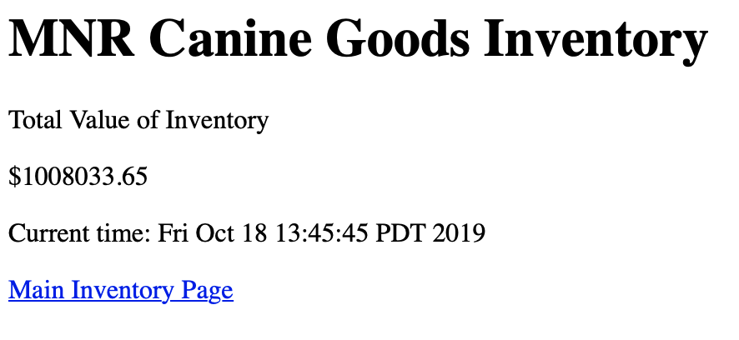

**If you add a new product, then you will see a new product on the list, such as MNR028.**

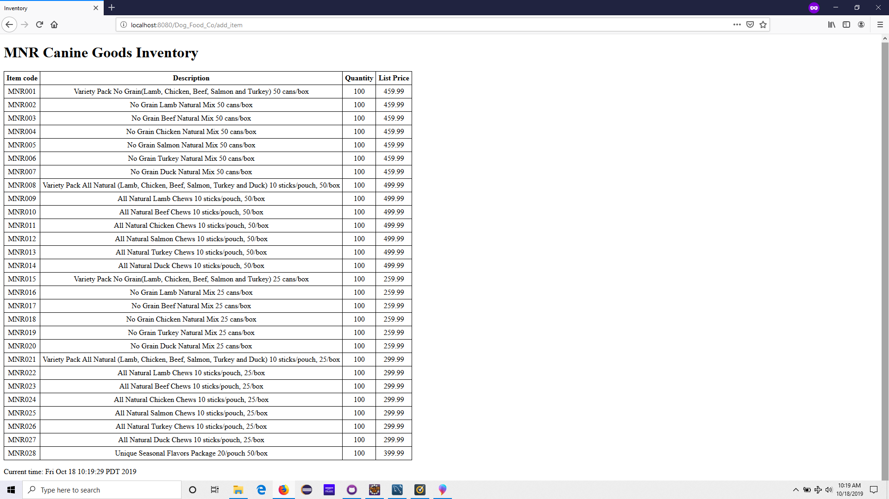

**If you decide to delete a product, such as MNR028, you will end up seeing the inventory page without it.**

